T8 Grow Light LED Tube IP65 Waterproof Specification

Table of Contents
(1)Product features……………………1
(2)Technical parameters………………2
(3) Outline dimension drawing…………3
(4)Installation instructions………………4
(5) Packing size…………………………5
(6) Attention Matters……………………6
(7)Spectrum Data (90CM) …………8

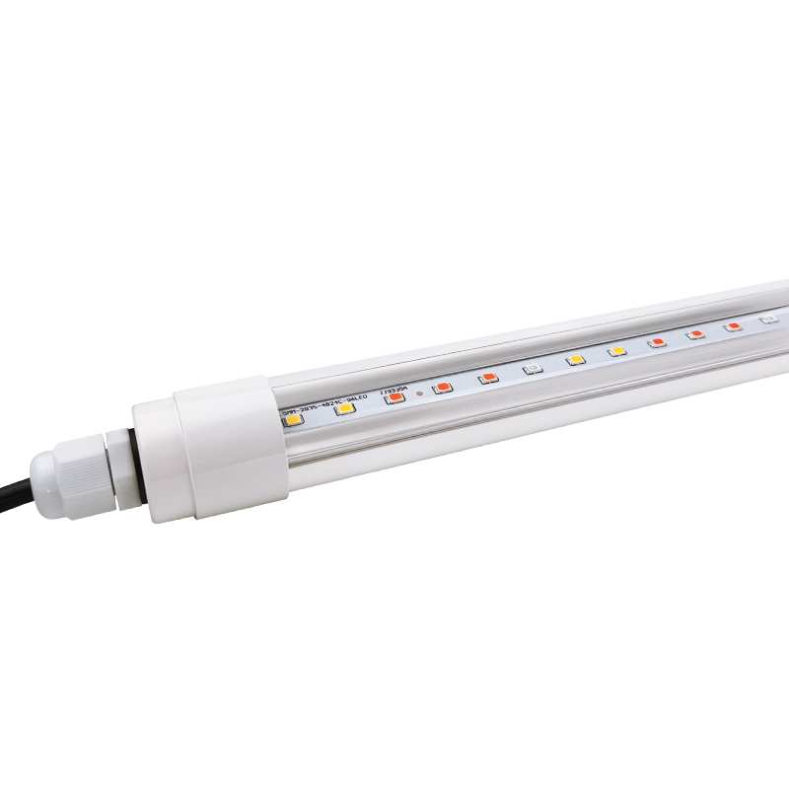
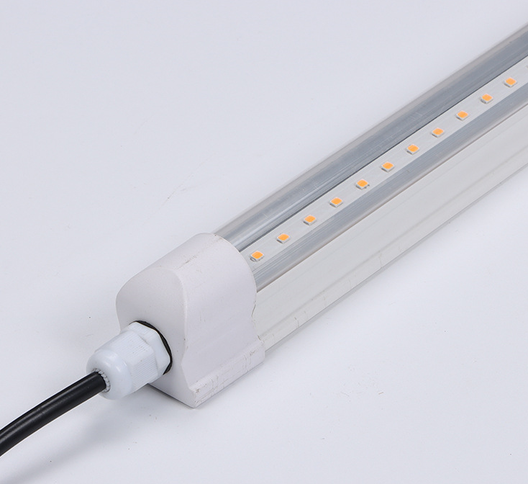

Please refer to: https://www.7colorstek.com/how-to-select-t8-led-grow-lights/

- Product features
※Adopting advanced LED semiconductor lighting technology, 70% energy saving than traditional fluorescent lamps;
※Using imported high-efficiency SMD LED lamp beads;
※The lamp body is made of high-thermal conductivity plastics and White finish. The appearance is simple and fashionable. Does not change color.
※Excellent thermal management can effectively ensure the long-term stable operation of LED lights and effectively control light attenuation problems.
※Power overload protection design, low current and low voltage operation, higher safety performance;
※Ultra-long life design, can reach 30,000 hours, which is 17 times the life of traditional fluorescent lamps;
※Easy to install, convenient to use, no need to replace the lamp, can be directly replaced Traditional fluorescent lamps；
※green products, do not contain lead, mercury and other heavy metals and harmful gases;
※use DC drive, no flicker, effectively protect eyesight;
※no ultraviolet radiation and electromagnetic radiation, safer to the human body.
※Products are widely used in both indoor and growing in greenhouse, garden, home, planting farm, planting factories etc., and are ideal substitutes for traditional fluorescent lamps.
※LED Grow Light Knowledge
※ 1.Different wavelengths of light have different effects on plant photosynthesis. The light required for plant photosynthesis has a wavelength of about 400-700nm. 400-500nm (blue) light and 610-720nm (red) contribute the most to photosynthesis.
※2. Just use these two color combinations. In terms of visual effects, the red and blue plant lights are pink. Our full spectrum led grow lights just base on these main wave length, and the wave peak is 650nm. We also add some other useful spectrum like 380nm UV, 570nm Green,730nm IR in to make it wide enough to fit for any stages of every plants.
※3. Blue light can promote the growth of green leaves; red light can help blossom and fruit and prolong the flowering period!
※4. When plant lights are used to supplement light for plants, the height from the leaves is generally about 0.5 meters, and continuous exposure for 12-16 hours a day can completely replace the sun
※Special Feature
※ ◎Reduce cultivation costs and extend flowering period
※ ◎Promote early maturity of plants, increase production, and improve the quality of fruits
※ ◎Ensure the taste of greenhouse vegetables and realize off-season cultivation
※ ◎Inhibit the reproduction of germs and pests, reduce the amount of pesticides, green and pollution-free
(2)Technical parameters(90cm Integrated LED Grow Tube Light)
Item No. | SC-T8WP-03S | SC-T8WP-03D
Power | Single Row 14W±0.5 | Double Row 28W±0.5
Driver Type | Built-in No-isolated
PF | PF≥0.9
EF | ≥85%
LED QTY | 72PCS | 144PCS
Size mm | 900mm | 900mm
Material | Plastics+Built-in Alu Profile+Transparent PC
Working Temp | -20~50℃
Storage Temp | -30~50℃
Input Voltage | AC100-240V,47Hz to 63Hz
Lighting View | 120° | 120°
IP Rating | IP65
Warranty | TWO YEARS
PPFD(20cm Height) | 42µmol/m²s | 52µmol/m²s
Wave Length | 380-840nm
Spectrum | Full Spectrum
Application | Any stage of any plants
Certificate | LVD,CE,&ROHS

- Outline dimension drawing
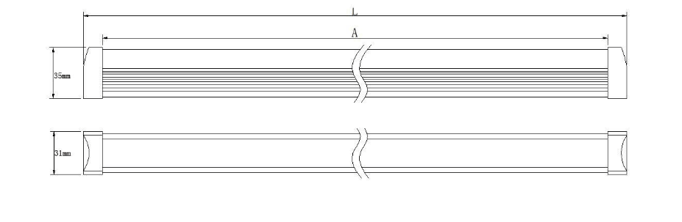

L=300mm,600mm,900mm,1200mm,1500mm
- Installation instructions
For T8 integrated LED Grow Lights, it is very easy to install.
- You just need to take the traditional tube fixtures first.
- Fix the clips with screws
- Install the integrated tube lights on the clips
- Wire the cable to the power and finish

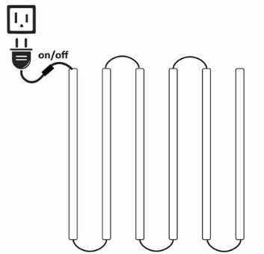
How to connect
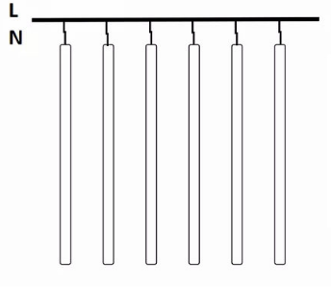

Brown cable for L, Blue one for N, and Yellow for Ground
You can also connect them in series
- Packing size
With Color Box
Item No. | QTY/CNS | N.G(KG) | G.W(KG) | Packing Size(mm)
SC-T8WP-03S | 30pcs | 8 | 9 | 94X23X20CM
SC-T8WP-03D | 30pcs | 9 | 10 | 94X23X20CM
With Paper Pipe
Item No. | QTY/CNS | N.G(KG) | G.W(KG) | Packing Size(mm)
SC-T8WP-03S | 20pcs | 9 | 10 | 94X23X23CM
SC-T8WP-03D | 20pcs | 11 | 12 | 94X23X23CM
- Attention Matters
※The working voltage of the lamp is AC100-240V, please make sure that the working voltage is within this range when connected to the power supply. Connecting to a higher voltage will cause permanent damage to the lamp.
※After connecting the power supply, prohibit any contact metal from touching the bottom of the bulb to avoid electric shock
※After unpacking or before use, please check whether the lamp is damaged due to transportation. If so, please stop the application and notify the supplier, this product can only be used in perfect condition
※In order to ensure the safe and normal use of the product, please strictly abide by the explanations and precautions in the manual, and the supplier shall not be liable for any losses caused by illegal operations.
※When in high heat environment, please do not connect the bulb and power supply, and when the working temperature exceeds a certain temperature, its life will be greatly shortened, it is recommended to use this product at room temperature
※Before installation, please ensure that the local installation environment supports this product. It is recommended to install it in a stable place to prevent vibration and shaking.
※Since the surface temperature of the lamp can reach 50°C, it is recommended that there is no heat sensitive equipment around the lamp. To ensure proper working temperature, please keep the product away from heat sources and use this product in a mild environment.
- Spectrum Data (90CM) Tested by Taiwan Asensetek Lighting Passport
90cm white 5000-5500K single row 14W
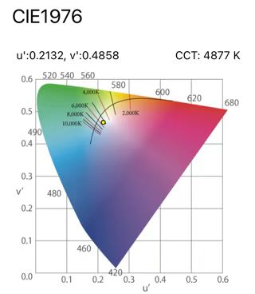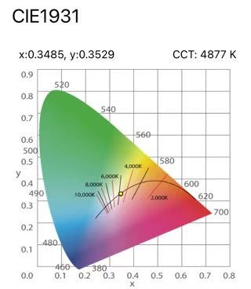

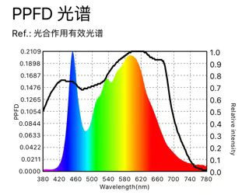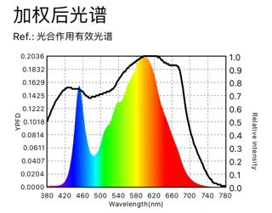

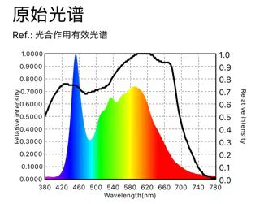
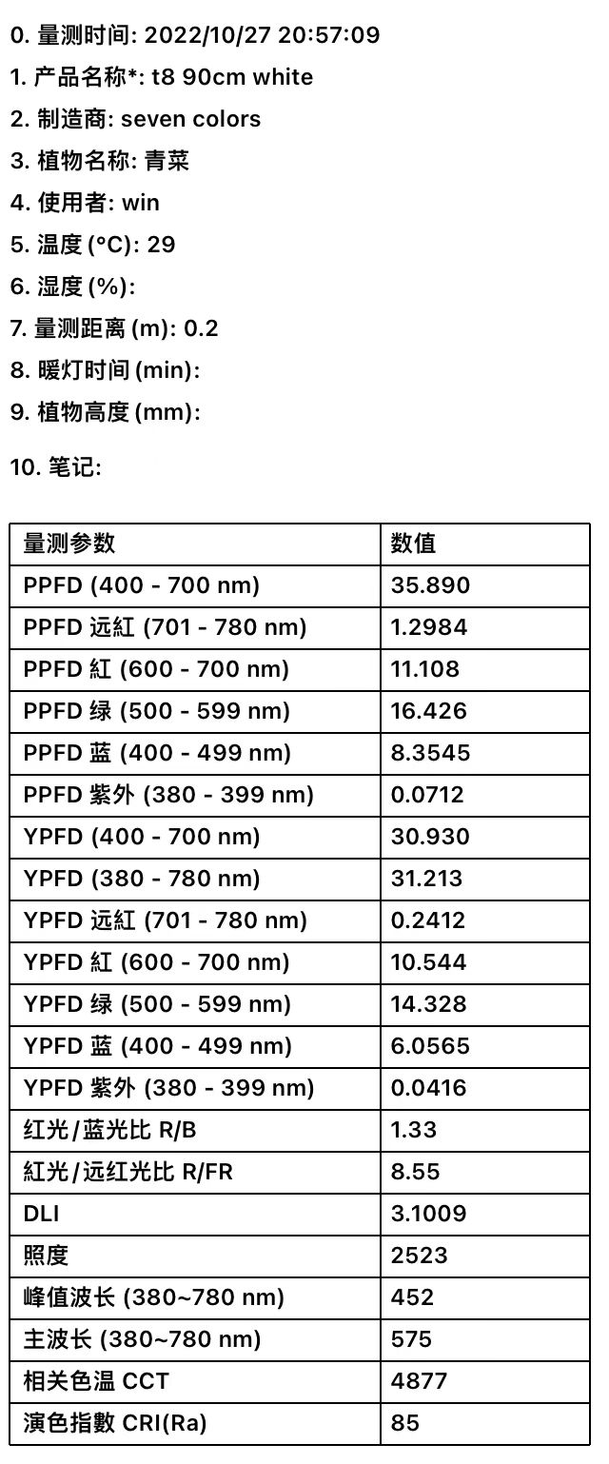

90cm full spectrum double row 28W
